Here is a screenshot of what we do want. The *Risk Factors for Bladder Cancer* module provides the text “Anything that increases…as you get older.” that follows the Key Point “Smoking can affect the risk of bladder cancer.”

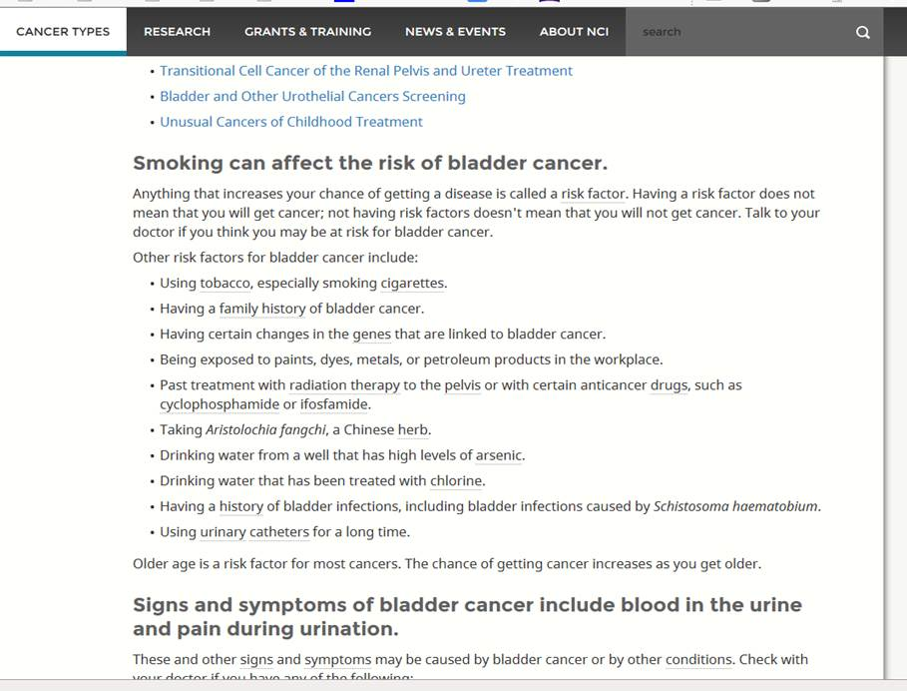

If the module title (“Risk Factors for Bladder Cancer”) were included, it would immediately follow the KP where a title is not wanted. See the QA PubPrev screenshot below. (Also, a title is not ordinarily an allowed element within a KP section).

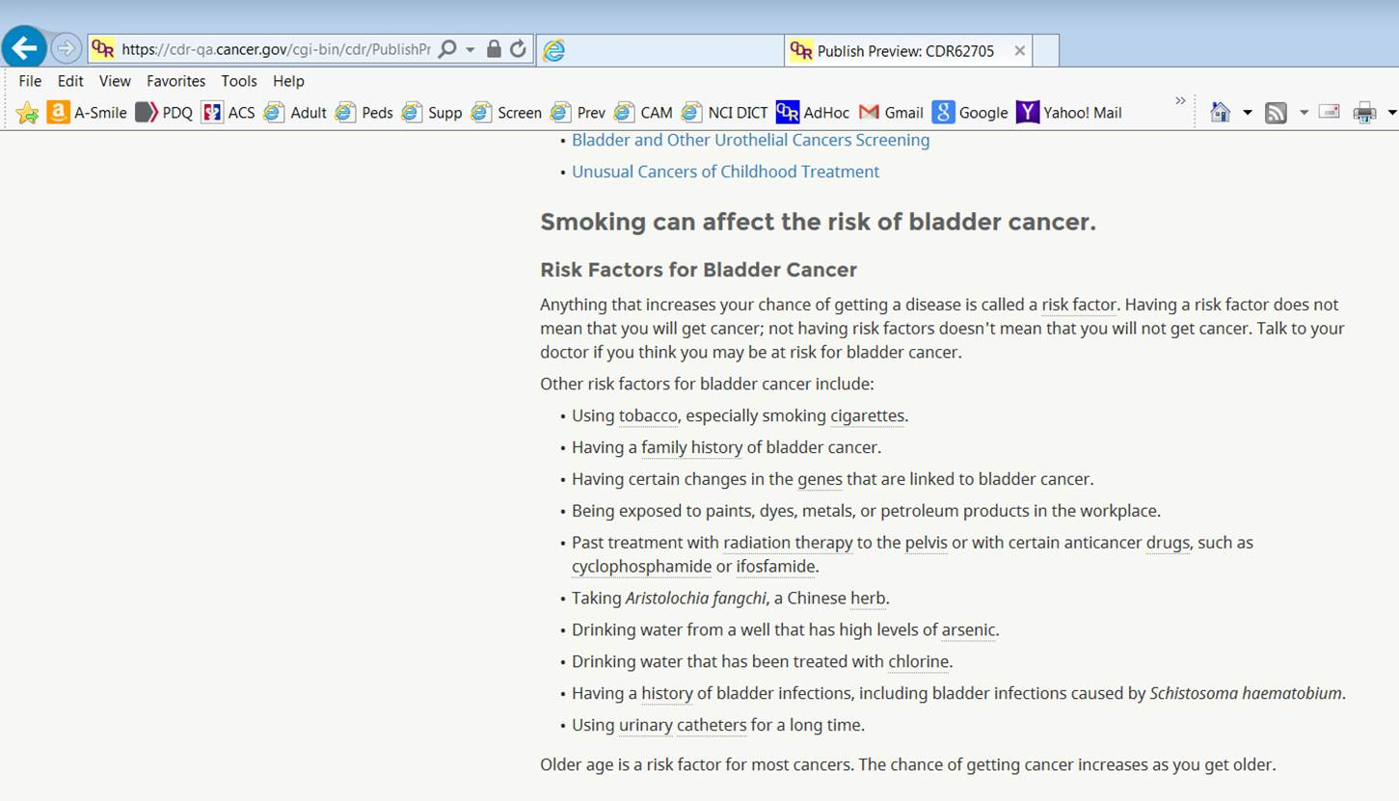

This is what would appear in the TOC. Only the risk factor info would get a subhead in the TOC for the General Info section. Which doesn’t make sense; RFs are not the most important KP in that section so no reason they should be highlighted in that way. 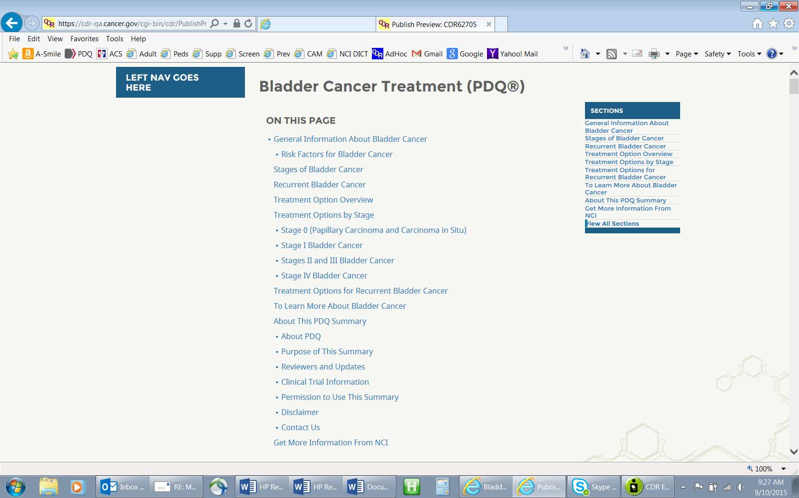

**QA doc numbers:**

**Bladder module    751733**

**Bladder summary 62705**